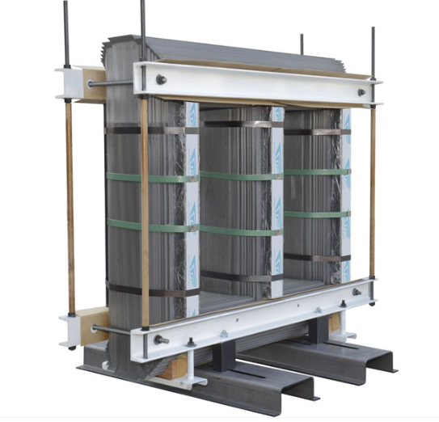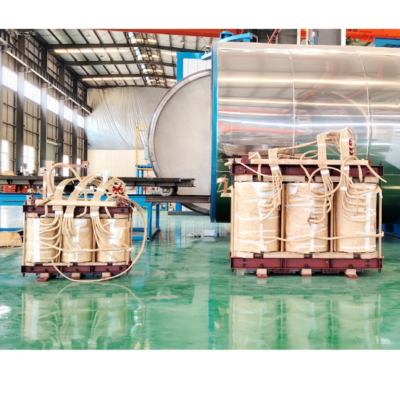

Transformer Cores: The Metal Hearts of Electrical Magic
If transformers had hearts, the core would be it—working quietly but crucially at the center of all the action. Without the core, a transformer is like a superhero without powers. But not all cores are created equal! From traditional silicon steel to the slick, energy-saving non-crystalline amorphous metal, the core is what keeps your transformer efficient and happy. Let’s dive into the wonderful world of transformer cores, from the old school to the cutting-edge.

The Transformer Core: What Is It?
In simple terms, the transformer core is the part of the transformer that helps convert electrical energy by guiding magnetic flux between windings. Think of it as the transformer’s highway system for magnetic energy. Without a good core, electrical energy would be a chaotic mess—sort of like trying to drive on a freeway without lanes!
But like any good road, the material and structure of the core affect how well it works. Let’s break it down by core types and what makes each one special.

Silicon Steel Core: The Old Reliable
First up, we’ve got the silicon steel core. This is the granddaddy of transformer cores—reliable, affordable, and still widely used today. Made from laminated sheets of silicon steel, it’s the "workhorse" of transformer materials. These sheets are stacked together, with an insulating layer between them to reduce energy losses due to eddy currents (tiny, mischievous currents that like to steal energy if you're not careful).
- Pros: Affordable, effective for most applications, and widely available.
- Cons: Not as energy-efficient as newer materials. It’s like the classic car of transformer cores—gets the job done but might not have the best fuel economy.
Where you’ll find it:
- Distribution transformers: In your neighborhood, keeping your lights on.
- Power transformers: In substations, converting voltage levels like a pro.

Amorphous Alloy Core: The Slick, Modern Hero
Now, if silicon steel is your old reliable workhorse, amorphous alloy (or non-crystalline) core is your futuristic sports car—smooth, energy-efficient, and designed to turn heads. Unlike silicon steel, which is made from grain-oriented crystals, amorphous alloy is made from a "molten metal soup" that’s cooled so rapidly it never has time to crystallize. This creates a super-thin ribbon that can be wound into a core, reducing energy loss dramatically.
- Pros: Super low core losses, making it great for energy-saving transformers. Perfect for eco-friendly power grids!
- Cons: More expensive, and trickier to manufacture. It’s like the high-tech gadget you want but might not need for every situation.
Where you’ll find it:
- Energy-efficient transformers: Often used where energy savings and lower operational costs are top priorities. Great for modern, smart grids where every watt counts.
- Renewable energy applications: Wind and solar power systems love these cores because they minimize energy loss.

Nanocrystalline Core: The New Kid on the Block
If the amorphous alloy core is a sleek sports car, the nanocrystalline core is like a high-end electric car—cutting-edge, super efficient, and designed for maximum performance with minimum energy use. Nanocrystalline materials are made from ultra-fine crystals (yes, we’re talking nanometers) and offer even lower energy losses than amorphous cores.
- Pros: Even lower core losses than amorphous alloy, higher magnetic permeability, and great for high-frequency applications.
- Cons: Yup, even pricier. Also not as widely used yet, but it’s gaining ground.
Where you’ll find it:
- High-frequency transformers: These babies love nanocrystalline cores, as they’re excellent at reducing energy losses when operating at higher frequencies.
- Precision applications: Used where efficiency and precise magnetic properties are key, such as in advanced medical equipment and aerospace tech.

Toroidal Core: The Doughnut of Efficiency
Next, we’ve got the toroidal core, which is shaped like a doughnut—and honestly, who doesn’t love a doughnut? Toroidal cores are super-efficient, as their round shape makes them great at containing magnetic fields, reducing "leakage" that wastes energy.
- Pros: Compact, efficient, and great at reducing noise and energy loss.
- Cons: Trickier to manufacture and wind than other cores. A bit like trying to neatly wrap a present... but round!
Where you’ll find it:
- Audio equipment: Perfect for high-quality sound systems that need minimal interference.
- Small transformers: Used in everything from power supplies to medical devices where efficiency and compact size matter.

The Core’s Role in Transformers: More Than Just a Pretty Face
Regardless of the type, the core’s job is to keep energy losses low while transferring power efficiently. In transformer terms, we’re talking about minimizing hysteresis losses (energy lost from constantly magnetizing and demagnetizing the core) and eddy current losses (those pesky little currents that heat up the core like a bad sunburn).
But beyond just keeping things efficient, the right core material can also:
- Reduce noise: Transformers can hum, buzz, or sing (not in a good way) if the core isn’t designed well.
- Cut down on heat: Excess heat = wasted energy, and no one likes paying extra for power they didn’t get to use.
- Lower maintenance: A good core means fewer breakdowns and longer transformer life—like giving your transformer a solid workout routine and a healthy diet.

Conclusion: Choosing the Right Core for the Job
So, whether your transformer is the steady workhorse of the grid or the sleek, energy-efficient model for the future, choosing the right core is a game-changer. From silicon steel to amorphous alloy and even the nanocrystalline core, each type has its place in keeping the world powered up and efficient.
Remember, the transformer core is more than just metal—it's the unsung hero that keeps everything running smoothly, like a good cup of coffee for your morning! So the next time you walk past a transformer, give it a nod of appreciation—it’s got a strong core working hard to keep your lights on.
#TransformerCores #AmorphousAlloy #SiliconSteel #Nanocrystalline #EnergyEfficiency #PowerTransformers #MagneticHeroes

**变压器铁芯：电力魔法的金属心脏**
如果说变压器有心脏，那铁芯就是它的心脏——在一切运作中默默无闻却至关重要。没有铁芯，变压器就像一个没有超能力的超级英雄。但并非所有铁芯都生而平等！从传统的硅钢到光滑节能的非晶合金，铁芯是保持变压器高效和稳定运行的关键。让我们从经典到前沿，深入探索变压器铁芯的奇妙世界。

**变压器铁芯是什么？**
简单来说，变压器铁芯是变压器的一部分，通过引导绕组之间的磁通来帮助转换电能。可以把它想象成变压器磁能的“高速公路系统”。如果没有一个好的铁芯，电能就会变得混乱不堪——就像在没有车道的公路上开车一样！

但就像任何一条好路一样，铁芯的材料和结构会影响其性能。让我们按铁芯类型来分解，看看每种铁芯的独特之处。

**硅钢铁芯：经典可靠之选**
首先，我们有硅钢铁芯。这是变压器铁芯的“老前辈”——可靠、经济实惠且至今仍被广泛使用。它由硅钢片叠压而成，是变压器材料的“主力军”。这些硅钢片堆叠在一起，中间夹有绝缘层，以减少涡流（那些如果不小心就会偷走能量的小调皮电流）造成的能量损耗。
- **优点**：价格实惠，适用于大多数应用，且广泛可用。
- **缺点**：能效不如新材料高。它就像变压器铁芯中的经典汽车——能完成任务，但燃油经济性可能不是最好的。

**常见应用场景**：
- **配电变压器**：在你的社区中，确保你的灯一直亮着。
- **电力变压器**：在变电站中，像专业人士一样转换电压。

**非晶合金铁芯：现代高效英雄**
如果说硅钢是可靠的老黄牛，那么非晶合金（或非晶态）铁芯就是未来的跑车——流畅、节能且设计引人注目。与由晶粒取向晶体制成的硅钢不同，非晶合金是由“熔融金属汤”制成的，冷却速度极快，以至于没有时间结晶。这形成了一种超薄带材，可以卷绕成铁芯，从而显著减少能量损耗。
- **优点**：铁芯损耗极低，非常适合节能变压器。是环保电网的理想选择！
- **缺点**：价格更高，制造工艺更复杂。就像你想要的高科技小工具，但可能并不适合所有情况。

**常见应用场景**：
- **节能变压器**：常用于节能和降低运营成本为首要任务的场景。非常适合现代智能电网，因为每一瓦都很重要。
- **可再生能源应用**：风能和太阳能系统喜欢这些铁芯，因为它们能最大限度地减少能量损失。

**纳米晶铁芯：新秀登场**
如果说非晶合金铁芯是流畅的跑车，那么纳米晶铁芯就像高端电动汽车——前沿、超级高效，专为以最低能耗实现最大性能而设计。纳米晶材料由超细晶体（是的，我们说的是纳米级）制成，其能量损耗甚至比非晶铁芯更低。
- **优点**：比非晶合金更低的铁芯损耗，更高的磁导率，非常适合高频应用。
- **缺点**：是的，价格更高。虽然尚未广泛使用，但正在逐渐普及。

**常见应用场景**：
- **高频变压器**：这些设备喜欢纳米晶铁芯，因为它们在较高频率下运行时能有效减少能量损耗。
- **精密应用**：用于效率和精确磁性能至关重要的场景，例如先进的医疗设备和航空航天技术。

**环形铁芯：效率的“甜甜圈”**
接下来是环形铁芯，它的形状像甜甜圈——说实话，谁不喜欢甜甜圈呢？环形铁芯非常高效，因为其圆形形状使其能够很好地包含磁场，减少能量浪费的“泄漏”。
- **优点**：紧凑、高效，且能有效减少噪音和能量损耗。
- **缺点**：制造和绕线比其他铁芯更复杂。有点像试图整齐地包装礼物……但它是圆形的！

**常见应用场景**：
- **音频设备**：非常适合需要最小干扰的高质量音响系统。
- **小型变压器**：用于从电源到医疗设备的各种场景，其中效率和紧凑尺寸至关重要。

**铁芯在变压器中的作用：不仅仅是好看**
无论哪种类型，铁芯的任务都是在高效传输电能的同时保持低能量损耗。在变压器术语中，我们谈论的是最小化磁滞损耗（由于铁芯不断磁化和退磁而损失的能量）和涡流损耗（那些像糟糕的晒伤一样加热铁芯的讨厌小电流）。

但除了保持高效之外，合适的铁芯材料还可以：
- **减少噪音**：如果铁芯设计不佳，变压器可能会发出嗡嗡声或噪音（不是好听的那种）。
- **降低热量**：多余的热量 = 浪费的能量，没有人喜欢为未使用的电力支付额外费用。
- **减少维护**：一个好的铁芯意味着更少的故障和更长的变压器寿命——就像为你的变压器提供一套坚实的锻炼计划和健康饮食。

**结论：为工作选择合适的铁芯**
因此，无论你的变压器是电网中稳定的主力军，还是未来节能高效的典范，选择合适的铁芯都是改变游戏规则的关键。从硅钢到非晶合金，甚至纳米晶铁芯，每种类型都在为世界提供高效电力方面发挥着重要作用。

记住，变压器铁芯不仅仅是金属——它是让一切顺利运行的幕后英雄，就像你早晨的一杯好咖啡！所以下次你经过变压器时，向它点头致意——它有一颗强大的铁芯，正在努力让你的灯保持亮着。

#变压器铁芯 #非晶合金 #硅钢 #纳米晶 #能效 #电力变压器 #磁能英雄

